

**CSE-3104: Peripherals and Interfacing Laboratory**

**Smart Gas Filling Station**

**Presented To**

**Dr. Md. Sheikh Sadi**

Professor

&

**S. M. Taslim Uddin Raju**

Lecturer

Department of Computer Science and Engineering

Khulna University of Engineering & Technology

**Presented By**

**Name:** Md. Mahfuzul Haque Gazi

**Roll:** 1707003

**Name:** Mahmudul Hasan

**Roll:** 1707015

Department of Computer Science and Engineering

Khulna University of Engineering & Technology

**Submission Date:** 20 January, 2022

Table of Contents

Title Page no.

1. Objectives 1

2. Introduction 1

3. Project Description

3.1 Project Details 1

3.2 Apparatus Required 1

3.3 Block Diagram 3

3.4 Source Code 3

4. Discussion 8

5. Conclusion 8

**1. Objectives:**

The main objective of this project are given below:

1. Try to build a prototype for a smart gas filling station.
2. Try to automate a gas filling station.
3. Build up a system where paying bills is more secure and safe.
4. Build up an user friendly gas filling station.

**2. Introduction:**

The rise in the amount of vehicles in the country in recent days has led to the traffic jams in each and every city. The transportation of vehicles at gas stations has caused a lot of difficulties anywhere in Bangladesh. Usually drivers pay the money with cash. But sometimes, they may pay more amounts due to lack of small money change on hand. This smart gas filling station is designed to reduce manual work and build up an automatic system to execute the task one after the other with RFID technology.

These systems are very much dependable and a smaller amount of time overwhelming strategy. The components used in this project are mentioned in section

**3. Project Description**

**3.1 Project Details:**

Everything has been digitized. In many existing systems, almost all gas stations have a controlling unit to perform the tasks like managing the electrical pump, drive the display, measure the flow & accordingly turn OFF the electrical pump. But still a person is required to collect the money and there is a possibility of many human errors. Moreover, it is risky to carry cash to fill the tank.In this proposed smart gas filling station system, we are using RFID card to access petrol at different petrol stations of different petrol companies across the country. Whenever we want to fill the tank from the fuel dispenser, we just have to place the RFID card near the RFID reader. Then the microcontroller reads the data from the RFID reader and performs the action according to the customer requirements. A keypad is used to input the amount of cash we want to pay. This digital petrol pump system also provides the security for the customers for filling petrol at the Petrol stations by avoiding the involvement of human beings as well as reducing the risk of carrying money every time. This petrol pump system consists of an Arduino Uno (with Atmega328p microcontroller), RFID module, LCD display, Keypad and led(to represent a pump). When the RFID reader reads a valid card it asks for the cash amount, if we enter a wrong card it gets denied. And when the amount is entered into the system, the LED turns on and gas gets filled in the tank from the fuel dispenser.

**3.2 Apparatus Required:**

The following equipments were used in our project:

| **SL** | **Name** | **Quantity** |
| --- | --- | --- |
| 01 | 16x2 LCD Display | 01 |
| 02 | I2C LCD Adapter | 01 |
| 03 | Arduino Uno | 01 |
| 04 | Matrix Keypad (4 X 4) | 01 |
| 05 | MFRC-522 RFID Module | 01 |
| 06 | Led | 01 |
| 07 | Breadboard | 01 |
| 08 | Connecting wire | As Required |

**3.3 Block Diagram:**

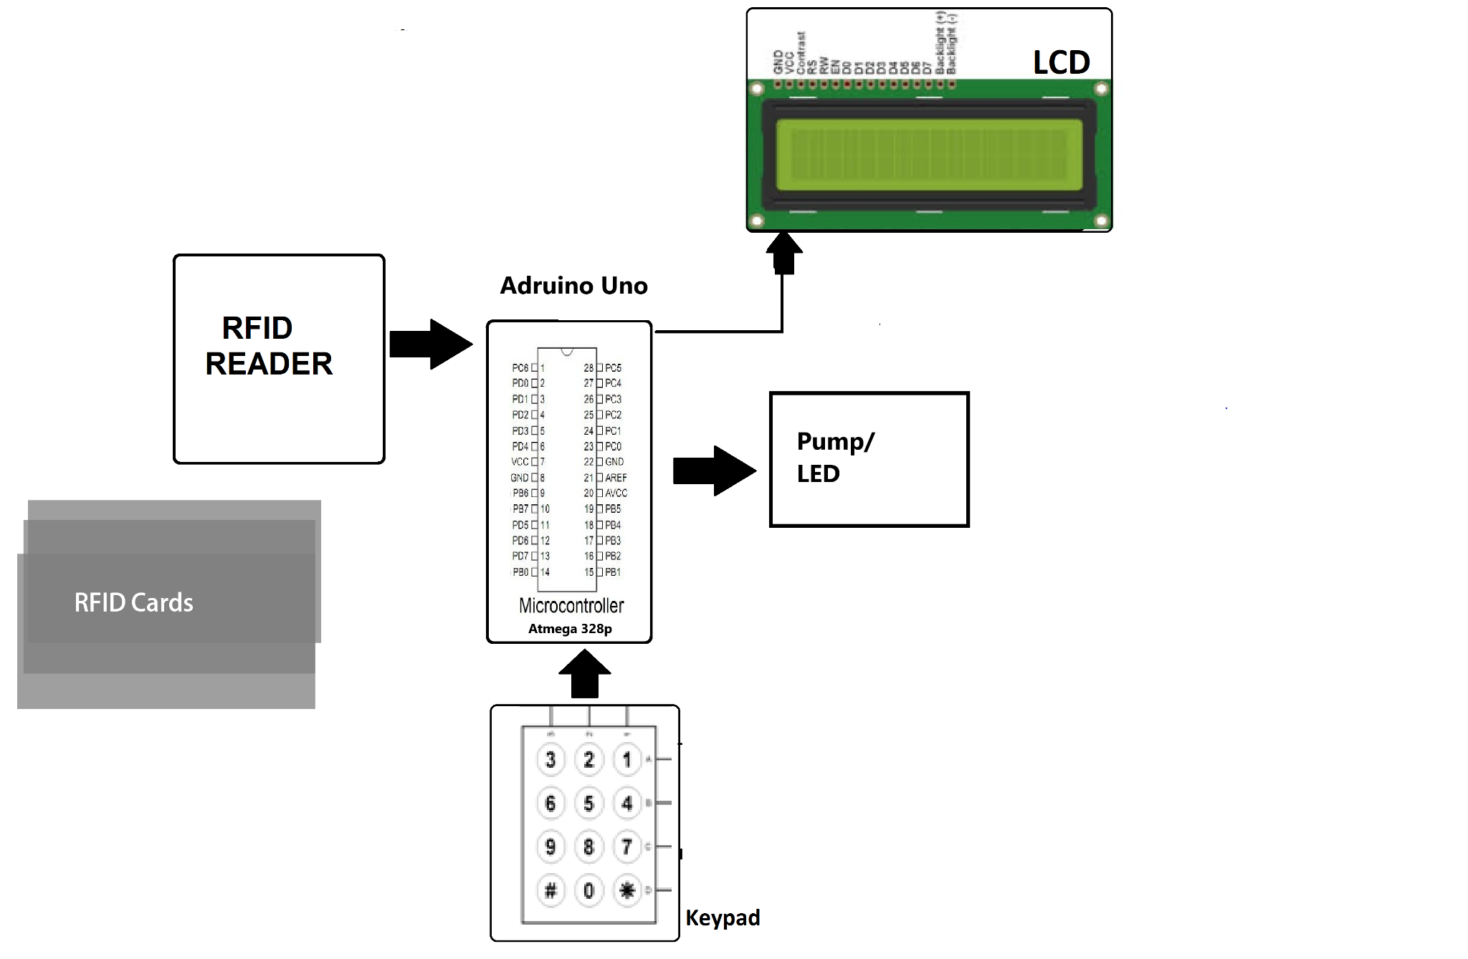

**Fig 1: Block diagram of our system**

**3.4 Source Code:**

// Include Arduino Wire library for I2C

#include <Wire.h>

// Include LCD display library for I2C

#include <LiquidCrystal_I2C.h>

// Include Keypad library

#include <Keypad.h>

#include <SPI.h>

#include <RFID.h>

#define SS_PIN 10

#define RST_PIN 9

RFID rfid(SS_PIN, RST_PIN);

String rfidCard;

// Constants for row and column sizes in keypad (4x4)

const byte ROWS = 4;

const byte COLS = 4;

char data[5];

byte count = 0;

int amount;

int led = 0;

// Array to represent keys on keypad

char hexaKeys[ROWS][COLS] = {

{'1', '2', '3', 'A'},

{'4', '5', '6', 'B'},

{'7', '8', '9', 'C'},

{'*', '0', '#', 'D'}

};

//Keypad Connections to Arduino

byte rowPins[ROWS] = {8, 7, 6, 5};

byte colPins[COLS] = {4, 3, 2, 1};

// Create keypad object

Keypad customKeypad = Keypad(makeKeymap(hexaKeys), rowPins, colPins, ROWS, COLS);

// Create LCD object

LiquidCrystal_I2C lcd(0x27, 16, 2);

//LCD Display Connection

// lcd sda = A4

// lcd SCL = A5

// vcc = vcc

// gnd = gnd

void setup(){

pinMode(led , OUTPUT);

digitalWrite(led, LOW);

// Setup LCD with backlight and initialize

lcd.backlight();

lcd.init();

//Serial.begin(9600);

//Serial.println("Starting the RFID Reader...");

SPI.begin();

rfid.init();

}

void loop(){

lcd.clear();

lcd.setCursor(4, 0);//lcd.setCursor(col, row);

lcd.print("Smart Gas");

lcd.setCursor(1, 1);

lcd.print("Filling Station");

delay(100);

if (rfid.isCard()) {

if (rfid.readCardSerial()) {

rfidCard = String(rfid.serNum[0]) + " " + String(rfid.serNum[1]) + " " + String(rfid.serNum[2]) + " " + String(rfid.serNum[3]);

//Serial.println(rfidCard);

if (rfidCard == "23 201 122 28") {

//Serial.println("RFID Reader: Card accepted!");

lcd.clear();

lcd.print("Card accepted!");

delay(1500);

lcd.clear();

lcd.print("Enter amount:");

while(1){

char customKey = customKeypad.getKey();

if (customKey){

lcd.print(customKey);

//Serial.println(customKey);

data[count] = customKey;

count++;

}

if(customKey == 'C' && count > 0){

lcd.setCursor(13, 0);

lcd.print(" ");

lcd.setCursor(13, 0);

count = 0;

}

else if(customKey == '*'){

count--;

amount = num();

//Serial.println(amount);

lcd.clear();

lcd.print("Amount =");

lcd.print(amount);

delay(1500);

int time = amount * 40;//time calculation in ms

digitalWrite(led, HIGH);//for motor or lcd to represent pump is on

lcd.clear();

lcd.print("Filing.");

int a = 0;

while(a < time){//delay time with an animation effect

delay(500);

lcd.print(".");

delay(500);

lcd.print(".");

delay(500);

lcd.setCursor(7, 0);

lcd.print(" ");

lcd.setCursor(7, 0);

a = a + 1500;

}

//LOW

digitalWrite(led, LOW);//for motor or lcd to represent pump is stopped

lcd.clear();

lcd.print(" Done Filling");

lcd.setCursor(3, 1);

lcd.print("Thank You!");

delay(3000);

break;

}

}

}

else {

// Serial.println("RFID Reader: Card Denied!");

lcd.clear();

lcd.print(" Card Denied!!");

delay(3000);

lcd.clear();

}

}

rfid.halt();

}

}

int num()//converts data-array into number

{

int n = 0;

int i = 0;

while(i < count){

n = n * 10 + data[i] - '0';

i++;

}

count = 0;

return n;

}

**4. Discussion:**

As shown in block diagram in section 3.3, the smart gas filling station is made up of four main parts: the card scanner, keypad(for input amount of money), pump/LED and LCD display. After scanning the valid card(ATM card),if it is accepted then the customer/user are requested to give an amount of money according to their neccessary .Finally the gas station supplies the gas.

The experimental result was satisfactory. It has been tested several times in several environments.

**5. Conclusion:**

We have successfully completed our project as planned before. The RFID worked well. Keypad and LCD also performed as expected. This system will provide better security to our day to day life.